Digital Math Lessons, Week 3, March 31-April 3
Monday and Tuesday
Adding and Subtracting Fractions- Standards NF.3a, NF.3d: Understand a fraction with a numerator >1 as a sum of unit fractions 1.
The screenshots below are from the math book. Please review them with your child, either for review or for an introduction of adding and subtracting fractions. Below the pages of explanation are videos that will explain the concept further. Assignments for practice have been assigned on Freckle.

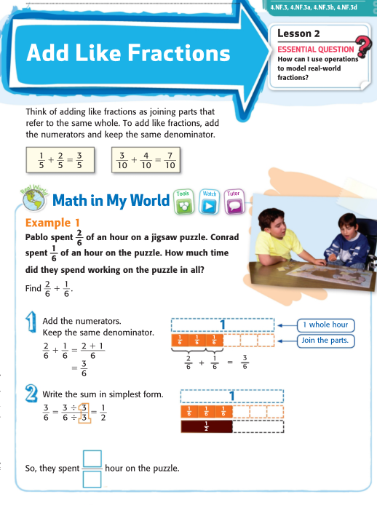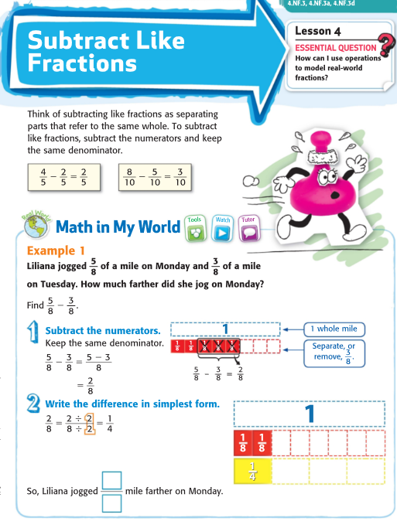
https://www.brainpop.com/math/numbersandoperations/addingandsubtractingfractions/

http://studyjams.scholastic.com/studyjams/jams/math/fractions/add-sub-common-denom.htm

https://www.khanacademy.org/math/arithmetic/fraction-arithmetic/arith-review-adding-subtracting-frac/v/adding-fractions-with-like-denominators
https://www.khanacademy.org/math/arithmetic/fraction-arithmetic/arith-review-adding-subtracting-frac/v/subtracting-fractions

Practice pages NF.3a, NF.3d:
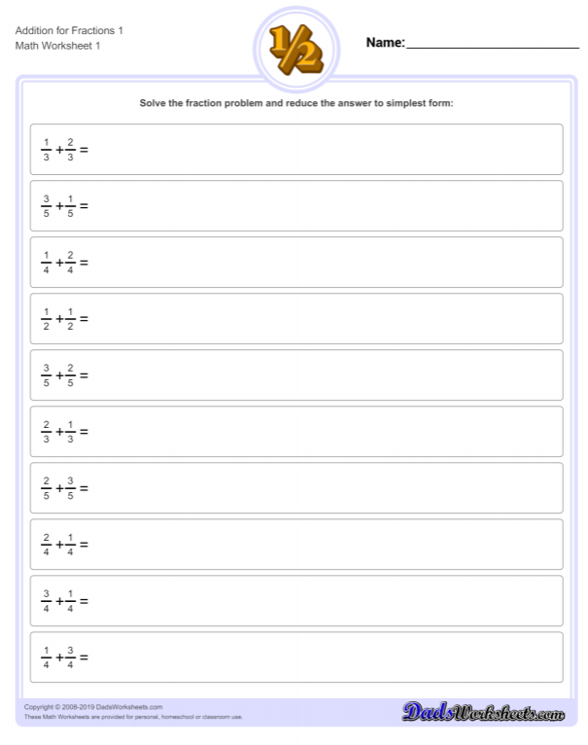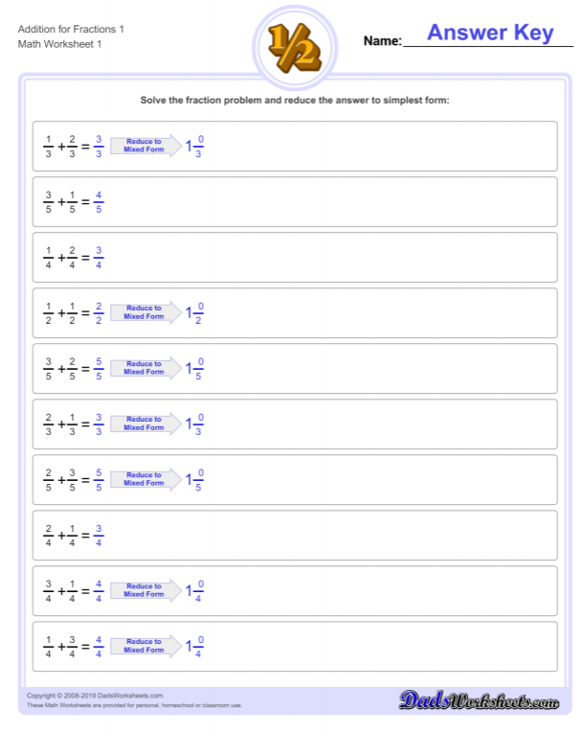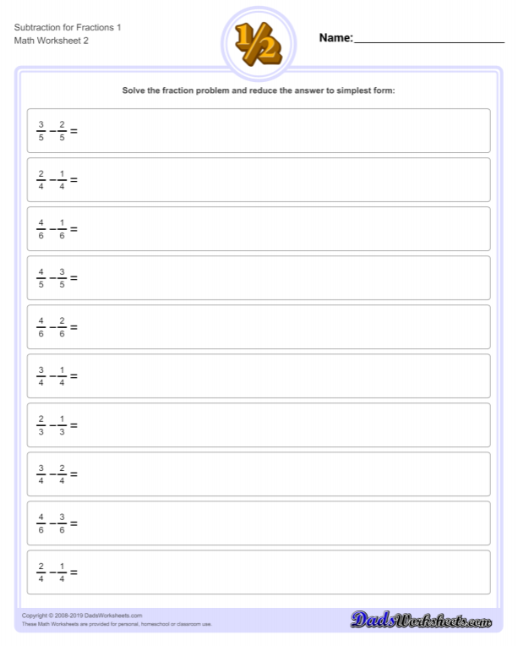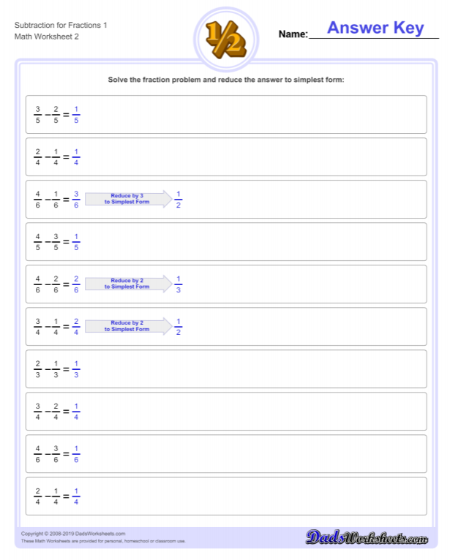
Freckle Fraction Assignments:
~NF.3a -Fractions- Add and Subtract Fractions; 10 Minute Fact Fluency
--------------------------------------------------------------------------------------
~NF.3d -Fractions-Add and Subtract Word Problems; 10 Minute Fact Fluency
Wednesday, Thursday, Friday
Fractions as decimals- Standards NF.5, NF.6, NF.7: Understand decimal notation for fractions and compare decimal fractions.
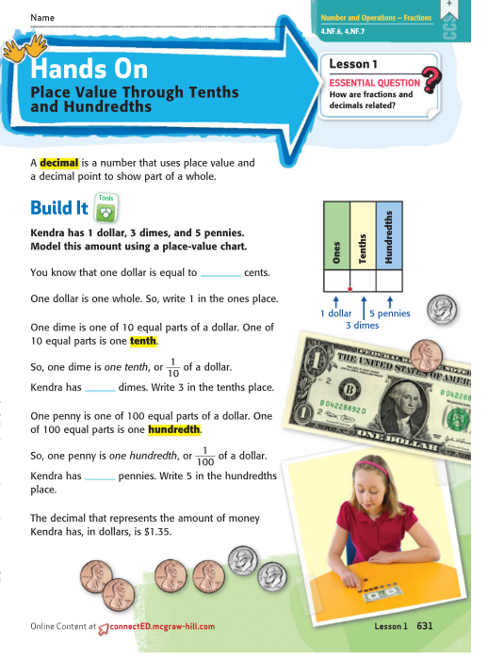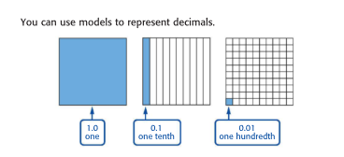

https://www.brainpop.com/math/numbersandoperations/decimals/

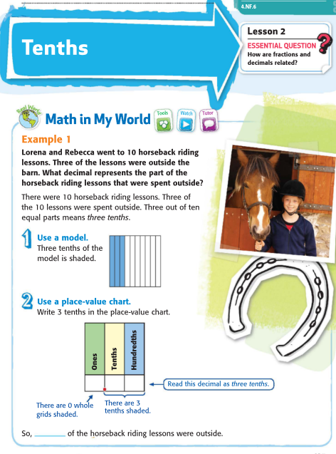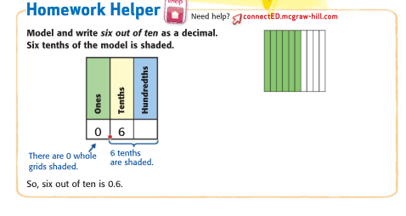
https://www.khanacademy.org/math/4th-engage-ny/engage-4th-module-6/4th-module-6-topic-b/v/visually-converting-from-tenths-to-hundredths

https://numberock.com/lessons/converting-fractions-to-decimals/

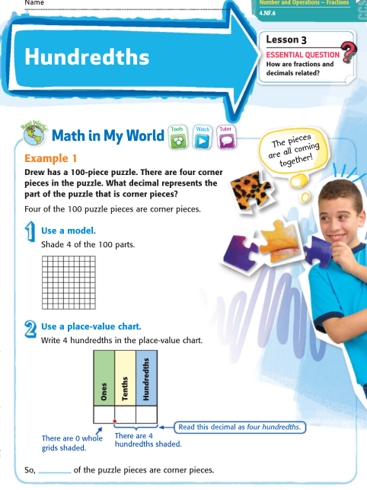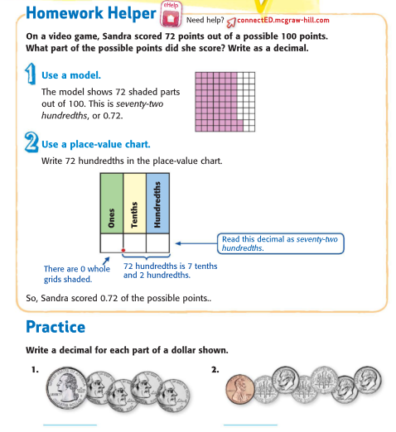

Practice on Khan Academy:
Equivalent fractions with fraction models:
https://www.khanacademy.org/math/4th-engage-ny/engage-4th-module-6/4th-module-6-topic-b/e/equivalent-fractions-with-denominators-of-10-and-100-intuition
Write fractions as decimals:
https://www.khanacademy.org/math/4th-engage-ny/engage-4th-module-6/4th-module-6-topic-b/e/converting_fractions_to_decimals_0.5

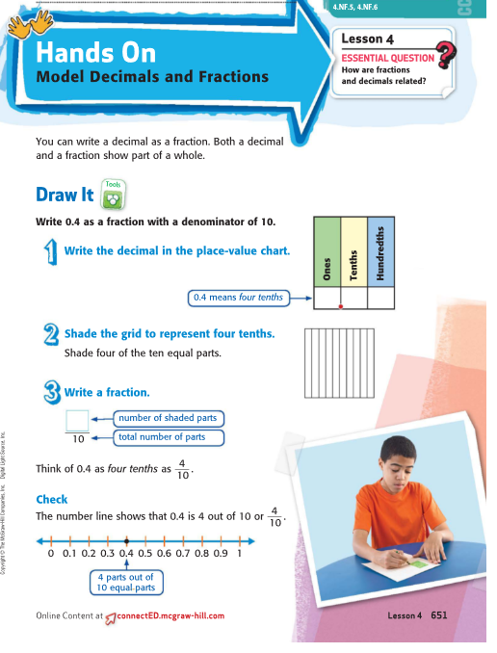

~Math Antics, Decimal Place Value: https://www.youtube.com/watch?v=KG6ILNOiMgM
~Decimals Place Value, Tenths and Hundredths: https://www.youtube.com/watch?v=ZwBoig-ACOg
~What is a Decimal? https://www.youtube.com/watch?v=xiMuFg9UqNY

~Comparing Decimals: Here's one: https://www.youtube.com/watch?v=w0or6RJrBWI
~This is a good one for comparing decimals. They included thousandths in addition to tenths and hundredths, but not too much. https://www.youtube.com/watch?v=RHUl4kZDD6c

Practice Pages NF.5, NF.6:
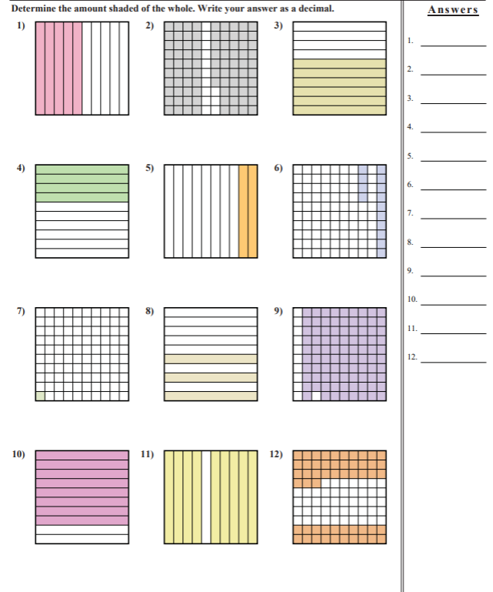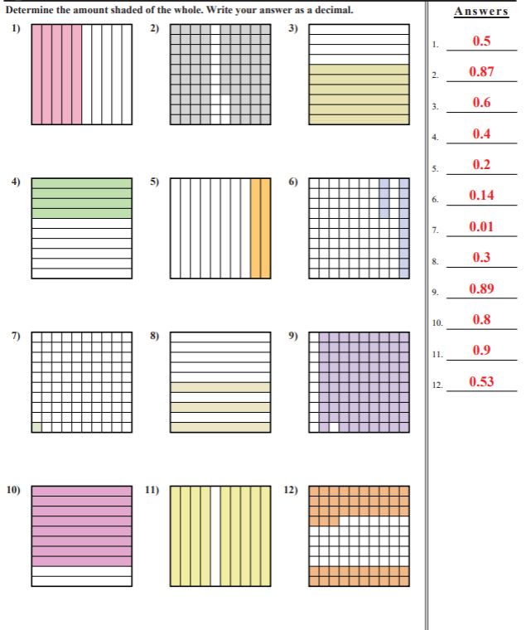
Practice Page NF.7:
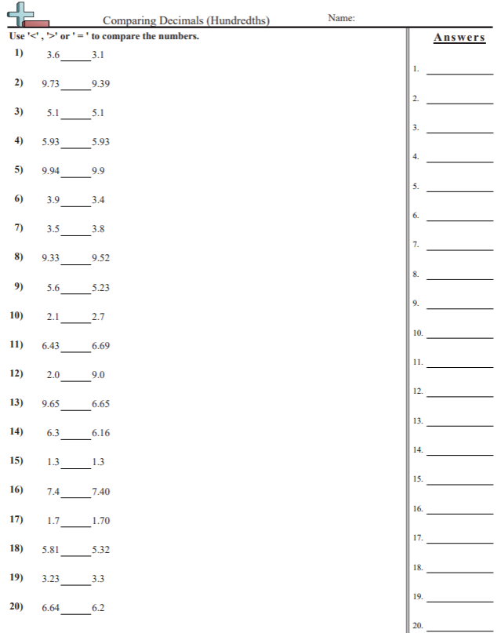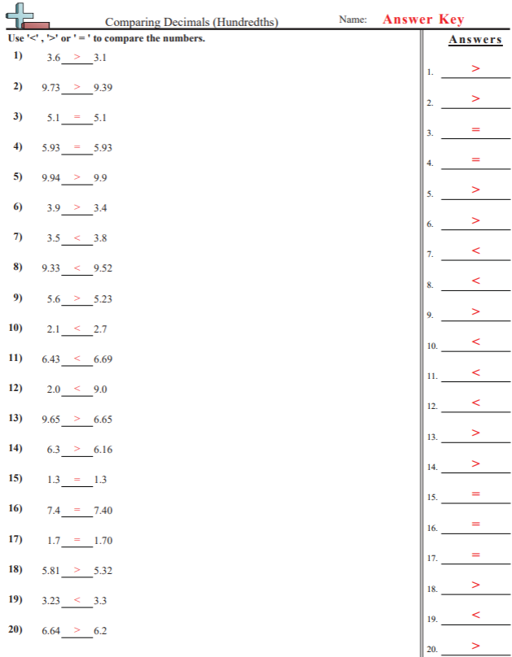
Freckle Decimal Assignments:
~NF.5-Fractions denominators 10 and 100; 10 Minute Fact Fluency
-----------------------------------------------------------------------------------
~NF.6-Fractions-Decimal Notation; 10 Minute Fact Fluency
-----------------------------------------------------------------------------------
~NF.7-Fractions-Comparing Decimals; 10 Minute Fact Fluency

**You can access the math textbook (McGraw Hill app) on Clever or from the Digital Resources link on our grade level blog. You can see the independent practice and homework pages that accompany these lessons and any other skills in which you might want extra practice. **

