Digital Math Plans April 13-17
Standard: MGSE4.G.1 (Points, lines, angles, etc.) **You can access the math textbook (McGraw Hill app) on Clever or from the Digital Resources link on our grade level blog.
Monday (Points, lines, and rays)
- View Brainpop video- https://www.brainpop.com/math/geometryandmeasurement/geometry/
- Read and review p. 873 of Volume 2 McGraw Hill math workbook
- Complete p. 874-875 in Volume 2 math workbook. (Screenshots below)
- Complete Freckle assignments found in backpack: Geometry Basics and 10 minutes fast practice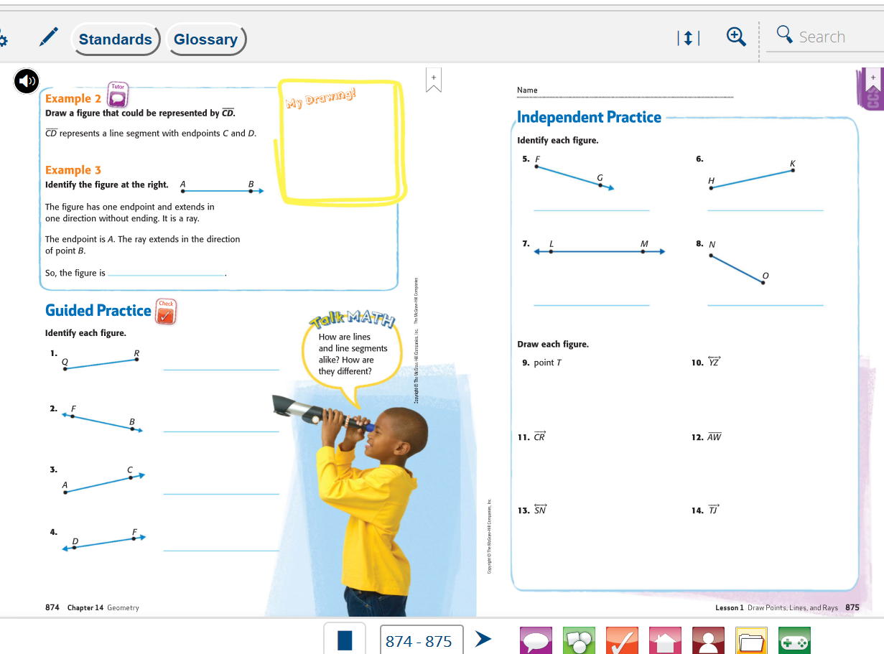

Tuesday (Parallel and perpendicular lines)
- Read and review workbook p. 879-880

- View “test yourself, sing Karaoke, and slide show” http://studyjams.scholastic.com/studyjams/jams/math/geometry/types-of-lines.htm
- Freckle assignments: Geometry Basics (lines) and 10 minutes of Fast Practice
Additional activities:
- p. 881-884 in math workbook
- Brainpop video- https://www.brainpop.com/math/geometryandmeasurement/parallelandperpendicularlines/
- Check My Progress p. 885-886 (Screenshots on next page)

Wednesday-Thursday (classifying and drawing angles)
- ***For Wednesday and Thursday lesson**, students will use their knowledge of lines and angles to plan and establish a medieval city.
After traveling back to the year 1510, students learn all about the new chartered city, Devonshire, a bustling hub for traders, craftsmen, and artists. Students use their knowledge of lines and angles to create a city map for Devonshire. With a completed city map, students help create a new tiltyard for jousting within the city walls. Every city during the Middle Ages needs a heraldic flag, and students design their own with the contest requirements in mind.

- View this video to identify the three types of angles (right, acute, obtuse)- http://studyjams.scholastic.com/studyjams/jams/math/geometry/classify-angles.htm
- Use screenshots (see below) from the math workbook to assist with identifying angles

Wednesday
Freckle Assignment:
- Please watch “Life in a Medieval City- Day 1” found in your backpack on Freckle and complete the graphic organizer below. Objective of day 1: Students will be able to identify and describe points, lines, line segments, rays and angles.

Thursday

- Freckle assignment: Please watch “Life in a Medieval City- Day 2” found in your backpack and complete the graphic organizer below. Objective of day 2: Students will be able to identify and describe lines and angles in two-dimensional shapes.

- Freckle Assignment: Please watch “Life in a Medieval City- Day 3” found in your backpack and complete the graphic organizer below. Objective: Students will be able to apply their understanding of lines and angles to complete a project that resembles a real-world situation.

For additional practice with angles:
- Freckle assignment: MGSE4.MD.5a - Angle Measurement
- Additional pages in math workbook to assist with drawing angles: p. 887-890

