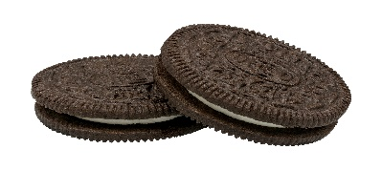OREO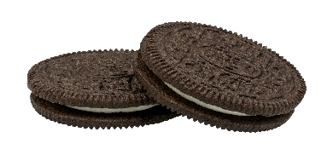
This Photo by Unknown Author is licensed under CC BY-SA
This Photo by Unknown Author is licensed under CC BY-SA
Opinion Writing
O
Hook- interesting beginning “catch the reader’s attention”

Reason 1 & transition | Example 1 & transition
Reason 2 & transition | Example 2 & transition
Reason 3 & transition | Example 3 & transition
Topic Sentence (State your Opinion)

E
R
O
Conclusion “restates your opinion”

